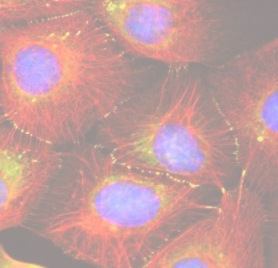

**Small Grant Program for Clinicians and Translational Research**

The Department of Dermatology is offering our faculty opportunities for awards through a new small grant program. The program is funded through a combination of the generosity of donors and department-run educational programs.

Applications are accepted on a rolling basis by our review committee. The program aims to:

* Foster clinical and translation research on skin diseases
* Encourage collaborative opportunities between our Dermatology clinical faculty with our basic science faculty and scientists in other departments within the medical school and the university

Eligible applicants are: a) clinicians who choose to investigate a skin disease-related problem; and b) any faculty scientist who proposes a project that engages a clinician in translational research that contributes to our understanding or potential therapy of skin disease. Proposals are encouraged to engage our resident trainees and to leverage the capabilities of our SBDRC cores. Priority will be given to studies that will lead to new funded skin-related grants. Studies are funded for one time up to $10,000. Renewals will be considered, depending on progress and continued support by philanthropic efforts.

Given our interest in diversity, priority will also be given to projects that fits into our Minority and Sex Awareness Program. Diversity proposals should focus on either: 1) Biological differences between skin from males vs. females or 2) the basic differences between skin from various ethnic and racial groups. Of note, cultured keratinocytes and other cutaneous cells (e.g. fibroblasts), as well as tissue from different sexes and ethnic/racial groups, are available through the SBDRC Core banks.

The **Skin Tissue Engineering and Morphology (STEM) Core** provides primary cultures of skin cells, particularly human and mouse keratinocytes, fibroblasts and melanocytes. This Core generates immortalized cells, induced pluripotent stem (iPS) cells, and 3-D raft cultures of human and mouse keratinocytes, including using disease-specific keratinocytes that can be co-cultured with melanocytes and/or fibroblasts. This Core also provides histopathology and immunohistochemical staining.

The **Translational and Experimental Skin Testing and Immune Tracing (TEST IT) Core** provides: (i) Immune monitoring (in vitro and in vivo in mice and humans); and (ii) an immunology-focused human studies facility for probing human disease and testing the impact of environmental agents and drugs prior to clinical trials. This Core also provides access to a tissue repository.

The **Gene Editing, Transduction and Nanotechnology (GET iN) Core** generates constructs to deliver: (i) cDNA; ii) stem-loop shRNA/MiR precursors; iii) mature RNAi; and iv) MiR inihibitors into skin cells. Vectors are available to: (i) generate iPS cells from skin cells; (ii) generate reporter cells for *in vivo* and *in vitro* cell tracking; (iii) simultaneously express multiple transgenes and shRNAs; and (iv) target expression by vectors with skin cell-specific promoters. CRISPR/Cas is delivered using viral constructs, as well as non-viral delivery of Cas protein. The Core also uses nanotechnology-based innovations to deliver material into skin cells and human skin.

For more information please visit our website at <http://skinresearch.northwestern.edu> for details on our SBDRC.

To apply, please use [this link](https://forms.feinberg.northwestern.edu/view.php?id=1141137) to upload a 2-page proposal with budget justification. If you have any questions or need further information, please contact Dr. Amy Paller ([apaller@northwestern.edu](mailto:apaller@northwestern.edu)), Dr. Robert Lavker ([r-lavker@northwestern.edu](mailto:r-lavker@northwestern.edu)),

or Dr. Kurt Lu ([kurt.lu@northwestern.edu](mailto:kurt.lu@northwestern.edu)).

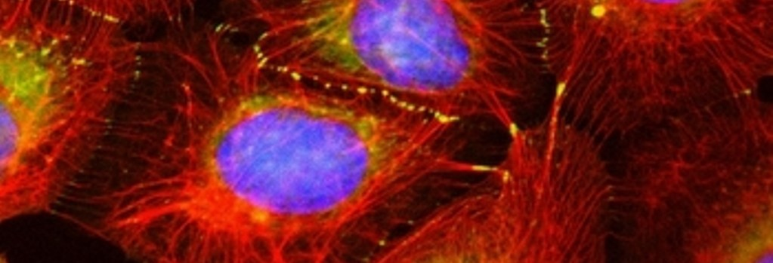

**Northwestern University Department of Dermatology &**

**Skin Biology and Diseases Resource-based Center**

