Navigation for Data Entry
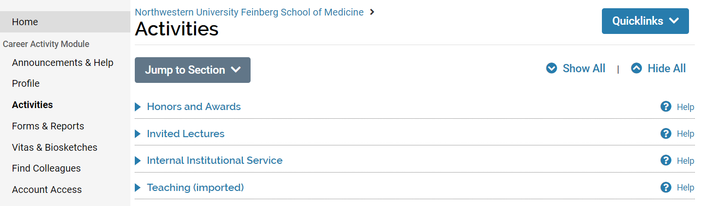
2
3
4
5
1

- Data entry occurs in the Profile and Activities pages. Click on either in the left navigation menu. The profile page contains sections that are relatively stable so need less updating over time. The activities page is where most career accomplishments are entered.
- The body of the page contains the list of sections where data entry occurs. Click on a section name to expand the section so that you can review, add, update, or delete records.
- Click on the question mark icon to view guidance for the section. On the activities page, guidance also appears when you expand a section.
- Press Show All to expand all sections or Hide All to collapse all sections.
- Press Jump to Section to search for and jump to a particular section.

Review and Update Data
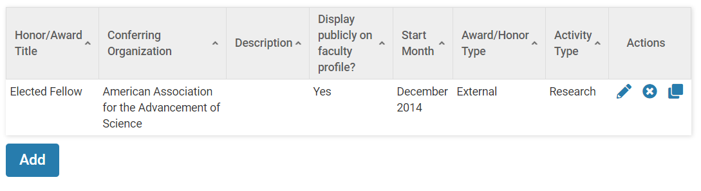
8
7
6

- Upon expanding a section, a summary table appears allowing you to review the data already entered. Click on a column header to sort by that column in ascending or descending order.
- Click the Add button to open a data entry form and enter a new record. (The button does not appear if manual entry of records is not allowed in the section.) Scroll to the bottom of the data entry form to press a Save option when you are done. Press Save and Add Another if you need to enter multiple records in succession.

- The Actions column at the right of the data summary table displays allowable actions for each record. For records imported from campus source systems, not all of these actions are allowed.
  - Click the pencil icon to edit a record.
  - Click the x icon to delete an existing record.
  - Click the overlapping squares icon to clone a record. This action creates a new record by copying an existing record and allowing you to make updates.

