Department:

Inclusion Criteria
1 | What groups of faculty will be included in the performance review cycle? | - Full-time/Academic Full-time Regular Faculty on the Clinician-Educator, Team Scientist, and Investigator tracks (required)
2 | Does your department have a minimum service requirement that new faculty must meet to be included in the review cycle, and if so, what is it? (e.g., review faculty who have been here at least 6 months)
Administrative Access
3 | List the administrators who need access to manage the performance review process. (Note: The department administrator should set up staff access; individuals who should see the performance review process need to have Full Admin Rights). | - Insert Names
4 | List the faculty who need administrative rights to review performance review submissions and record feedback. FAO will need to set up the rights for these individuals. At a minimum, the Chair will be on the list, but other such as Vice Chairs could have access, too. | - Insert Names
Performance Review Timeline
5 | Specify the target launch date. This is the date when the self-evaluation should become visible to faculty in the Feinberg Faculty Portal.
6 | Specify the target deadline for faculty to complete their self-evaluations.
7 | Following completion of the self-evaluation, the Department Chair/Division Chief should meet with each faculty member to discuss performance and then record a summary of performance feedback in the Feinberg Faculty Portal. Specify the target deadline for the Chair/Chief to document feedback for all faculty included in the review cycle.
Process Customization
8 | Specify the activity period that faculty should reflect upon in their self-evaluation. This should be a one-year period, typically preceding the launch of the self-evaluation process. For example, a review cycle that launches in September 2019 could ask faculty to reflect on activities over the period of September 2018 to August 2019.
9 | Specify the name of the workflow (this will display to faculty).  Suggested: [FY20] Performance Review for [Department Name]
10 | At the end of this document are screen shots of the standard performance review questions required by Feinberg. Departments may add a supplemental section that includes up to five additional questions. Will you include supplemental questions? Please list them.
11 | List in order the Feinberg Faculty Portal sections that you wish to include on the Performance Review Summary Form.
Additional Considerations
12 | For any academic full-time faculty appointed in your department, how will you coordinate with the affiliated sites (Lurie Children’s, SRALab, Stroger, Cook County) to complete faculty performance review?
13 | What is your plan for communicating the performance review process and timeline to faculty? Do you need to create department-specific guidelines/instructions?

Feinberg Faculty Self-Evaluation
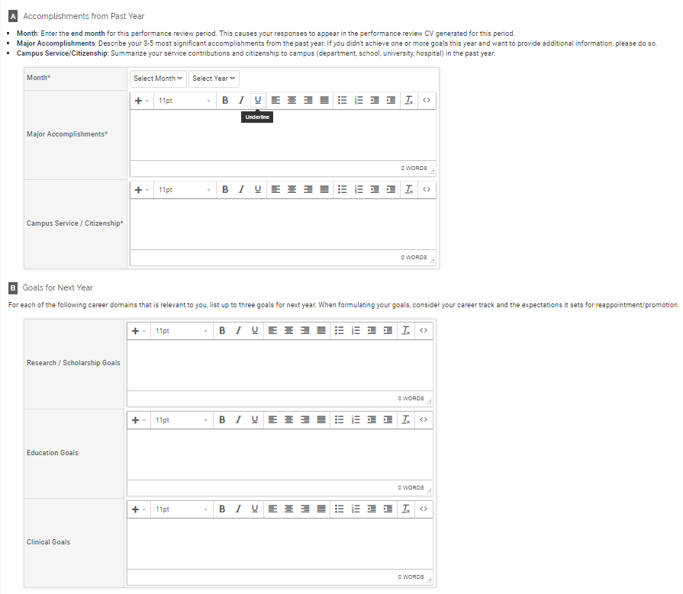
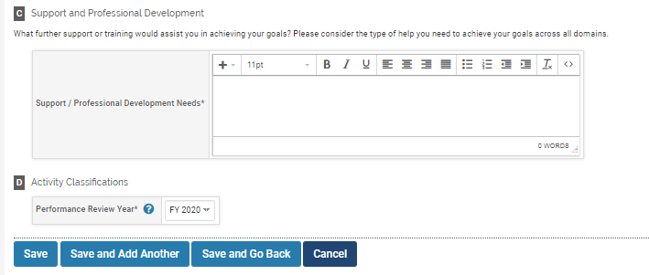
Feedback from Chair/Chief
