Feinberg School of Medicine
Guide to Managing Searches in the Faculty Recruiting System (FRS)
Last updated: 10/23/2018
This guide is intended to help Feinberg School of Medicine (FSM) staff manage faculty searches in the Faculty Recruiting System (FRS). The content applies when the following conditions are met:
- The search status is not pre-active in FRS (typically this guide will be used with searches that have active or hold status)
- You have either of the following roles for a given search:
  - Search Administrator or
  - Additional Search Committee Member/Administrator
Note: The permissions of additional administrators are customized by the Search Administrator, so dependent on Search Administrator preferences, additional administrators may not have access to all of the features described in this guide.
As a reminder, FSM recommends that you not ask faculty on the search committee to interact with FRS because it is a new system and we need to gain administrative experience with it. A staff member should monitor receipt of applications in FRS and distribute applications to the search committee chair/members for review. Every department should develop at least one staff member as a local expert in use of the system to assist search committees and other users of the system.
FRS Search Management Checklist
Required Tasks
Insert the FRS online job application link into the ad (see SECTION 2)
Note: Departments are responsible for executing the search strategy approved on the pre-search form
Monitor receipt of applications (see SECTION 3)
Important: FRS does not send email notifications when a new application is received, so a staff member
must regularly check FRS for new applications to each search.
Download applications to distribute to search chair/search committee members (see SECTION 4)
Designate candidates as finalists (see SECTION 10)
Enter final disposition codes (see SECTION 11)
Download the Search Summary Report (see SECTION 13)
Offer approval through FSM business plan database
Important: After a finalist is identified in FRS, use the FSM business plan database to complete the offer approval
process before extending an offer to a candidate.

Recommended Additional Features
Track applicant status / manage review process (see SECTION 7)

Contents

Essential Faculty Recruiting System (FRS) Features 3
1. Log in to FRS / Troubleshoot Login or Access Issues 3
2. Insert the FRS Online Job Application Link into the Ad and Distribute to the Search Committee 3
3. Monitor Receipt of Applications / Open an Application 4
4. Download an Applicant’s Materials for Distribution to the Search Committee 5
5. Update Materials for an Applicant 6
6. Refer/Copy Applicant to a Different Search 6
7. Track Applicant Status / Manage Review Process 8
8. Create Search Phases 8
9. Move Applicant to a Different Search Phase 9
10. Designate an Applicant as a Finalist 10
11. Enter Disposition Codes 11
12. Check How Many Applicants Need Final Disposition Codes Assigned Across Your Searches 13
13. Download the Search Summary Report 14
14. Place a Search on Hold / Prevent the Receipt of New Applications 14
15. Return a Search to “Active” Status from “Hold” Status 16
Revise Job Posting or Search Configuration Settings 16
16. Update the Advertisement Posted on the NU Careers Site 16
17. Update the MyHR Search Committee 16
18. Add Additional Search Committee Members/Administrators 17
19. Change the Order of Document Uploads in the FRS Job Application 17
20. Edit Search Details, Search Administrators, Search Contacts, or Search Options 18
Other Useful Features 18
21. Configure Dashboard 18
22. Create a Custom Tag to Categorize/Track Applicants 19
23. Enter, Edit, or Delete Administrative Notes on Applicant Records 20

Essential Faculty Recruiting System (FRS) Features
The initial section of this guide covers the aspects of the Faculty Recruiting System that administrative users are required to use or are likely to need in order to coordinate the search.

Log in to FRS / Troubleshoot Login or Access Issues

Log in to FRS (https://facultyrecruiting.northwestern.edu) with your netID and password. You will be required to establish multi-factor authentication (MFA) to log in, which is separate from the MFA instance used to log in to Northwestern University’s myHR system.
Troubleshoot Login or Access Issues
- I can’t log in
  - The most likely reason is that you have not been given access to a search in FRS. You will not be able to log in to the FRS system before you are granted access to at least one search.
  - Make sure that you are logging in with your university netID and password (not a hospital ID).
- I can’t find a specific search after successfully logging in
  - Searches go through several levels of review before they become visible in FRS. The search you are looking for may not have been approved for entry into FRS yet. Contact your department administrator if you need an update.
  - The department administrator who manages access to that search may not have given you access yet. Search access is managed separately for each search, and an authorized administrator must grant you access. Contact your department administrator.
- I can’t see some of the features described in this guide OR
I don’t have access to the same features across all my searches in FRS
  - The features you have access to are defined by your FRS role for each search. You might have different roles for different searches, meaning your permissions and access would be different across searches.
  - If you are assigned to the role of “Search Administrator” for a particular search, you have access to all the features described in this guide for that search. (All Department Administrators are given Search Administrator access and can grant that access to others.) If you are not listed as a Search Administrator for a particular search, then the Search Administrator has given you access as an additional administrator and has customized your permissions, possibly restricting what you can see and do.

Insert the FRS Online Job Application Link into the Ad and Distribute to the Search Committee

Note: Departments are responsible for executing the search strategy they proposed on the pre-search form and must include the link to the FRS online job application in the ad.
- Log in to FRS (https://facultyrecruiting.northwestern.edu) with your netID and password. If you experience login problems, consult SECTION 1 of this guide.
- You will land on the Dashboard screen. Configure your dashboard to display Active searches if they do not already display (SECTION 21). Active searches are approved by the Provost, posted on the NU Careers website, and have an active application link through which applicants can apply.
Note: Your ad is automatically posted to the NU Careers website and the Greater Chicago Midwest Higher Education Recruitment Consortium (GCM HERC) job board. NU does not automatically post to sites like Monster and Indeed, but you may find your ad on these sites which aggregate job postings picked up by their own internet search engines.
- Click on the Title of the search, which will open the Overview screen for that search.

- In the Search Details panel, confirm that the status is Active (otherwise the link won’t work). Then copy the Application URL and paste it into any advertisements you place in journals, online job boards, or other job posting venues.
- Double check to make sure you have posted the correct application link in the ad (especially important if you have multiple open searches, or if you are recycling a prior ad—update that link!).
- Distribute the ad with the correct FRS link to the search committee chair/members so they can refer applicants to it. It is highly recommended that you provide the committee the full ad. Faculty could be serving on multiple search committees at the same time, so if you provide the FRS link only, there is a greater likelihood that they will confuse which FRS link belongs to which search.

Monitor Receipt of Applications / Open an Application

Note: FRS does not send email notifications when a new application is received, so you need to regularly check FRS for new applications to each search.
- Log in to FRS (https://facultyrecruiting.northwestern.edu) with your netID and password. If you experience login problems, consult SECTION 1 of this guide.

- You will land on the Dashboard screen. Configure your dashboard to display Active searches if they do not already display (SECTION 21). “Active” searches are approved by the Provost, posted on the NU Careers website, and have an active application link through which applicants can apply.
The dashboard includes columns that show you the number of applications submitted for each of your searches. To display or hide these columns, see SECTION 21 on configuring the dashboard
  - Submitted: Total number of applications submitted for each search
  - 7-Day: Number of applications submitted in the last 7 days
  - Today: Number of applications submitted today

Optional: You may customize the columns that appear on your dashboard screen by clicking the Optional Fields dropdown list, selecting which additional columns you would like to see, and pressing the Set button. Pressing the Reset button will clear all customizations you made and revert your dashboard back to the system default.
- Click on the Title of the search you want to view. New options will appear in the top navigation bar, and you will find yourself in the Overview tab. A series of boxes provides counts of applications in certain statuses (note: these boxes look like buttons, but clicking them performs no action). The boxes colored in purple show the same counts you saw on the dashboard for the search selected:
  - Submitted: Total number of applications submitted for this search
  - 7-day: Number of applications submitted in the last 7 days
  - Today: Number of applications submitted today
- Click the Applications tab in the top navigation bar to access a list of applicants.
Optional: You may customize the columns that appear on the Applications screen by clicking the Optional Fields dropdown list, selecting which additional columns you would like to see, and pressing the Set button. If you have access to view or edit disposition codes, you can also filter the applications you see by using the Disposition Codes dropdown list and pressing the Set button after making your selections. Pressing the Reset button will clear all customizations you made and revert your dashboard back to the system default.
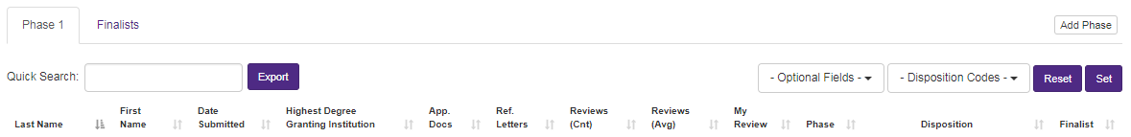

- Click the last name of an applicant to open that application.

Download an Applicant’s Materials for Distribution to the Search Committee

- Open an application (see SECTION 3).
- Make sure you are in the Applicant Information tab and click Download All Documents near the top of the screen. This will download a single PDF containing all documents submitted by the candidate. Within the PDF file, documents appear in the same order that they were listed on the application when applicants uploaded files.
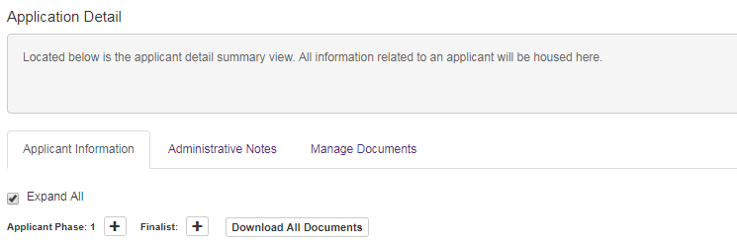
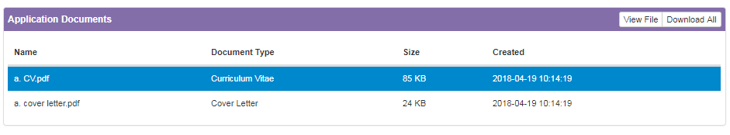
- If you need to download individual documents rather than downloading all documents in a single PDF, scroll down in the page until you get to the section called Application Documents. Click on one of the documents to select it (the row will turn blue). Then press the View File button to open/download that single file.

Update Materials for an Applicant

After submitting an application, applicants can no longer access the application to make revisions. However, administrators may add documents or update a completed application form:
- Open the candidate’s application (see SECTION 3).
- Click on the Manage Documents tab. From here you can replace existing documents or add documents that were optional for the candidate in the application form.
- If there is need to correct info the applicant provided in the online application form (e.g., the candidate has a new email address since applying), you can edit the data entered in the form fields:
  - Go to the Applicant Information tab.
  - The data in the panels for Official Contact Information and Academic Information can be edited by clicking the pencil icon in the upper right corner of each panel.

Refer/Copy Applicant to a Different Search

This process is used when candidates apply to one search, but you wish you to consider them for a different position. You may copy their application and document uploads to a different search in FRS so that the applicant does not need to submit a second application to be considered for the alternate position.
Pre-conditions for Copying an Applicant to a Different Search
- The search the application is being copied to must have Active status in FRS. (The search being copied from can have any status.)
- To copy an applicant from one search to another, you must have access to both searches in FRS. If you do not (e.g., you are referring an applicant to a search in another department), contact fao@northwestern.edu to request that an application be copied. Provide the applicant’s name, the HR Job ID of the search being copied from, and the HR Job ID of the search being copied to; also copy the department administrator from the other department on the email when making the request.
How to Copy an Application to Different Search
- Log in to FRS (https://facultyrecruiting.northwestern.edu) with your netID and password. If you experience login problems, consult SECTION 1 of this guide.
- You will land on the Dashboard screen. Configure your dashboard to display Active searches if they do not already display (SECTION 21) and locate the target search that should receive the copied application. Write down its HR Job ID.
- Next locate the search that originally received the application you want to copy. Click on the Title of that search.
- Click the Applications tab in the top navigation bar to access the list of applicants.
- Within the list, locate the applicant whose application you want to copy and press the Copy Applicant To button.
- Click on the Select Search dropdown list and select the HR Job ID of the target search that should receive a copy of the application. Note that if the original search had different required/optional document uploads, the target search will only receive the documents the two searches have in common. The target search will be missing any required documents that the original search did not also require. In that case, you could contact the candidate to collect additional materials by email and upload them to the application (see SECTION 5 of this guide).
- You will receive confirmation that the application has been copied, with an opportunity to view the copied application in the context of the HR Job ID that just received it.
- The applicant will have the disposition code Copied From Another Search in the target search that received a copy of the application.

- The system automatically adds an administrative note to the applicant’s record in the target search to document that the application was copied from another search. (For more information on administrative note, see SECTION 23.)

Track Applicant Status / Manage Review Process

FRS offers multiple mechanisms for tracking applicant status. The use of any of these mechanisms—by itself or in combination with others—is optional, but it is highly recommended that the staff member managing the search in FRS select one of these and use it consistently throughout the search to make sure that new applications are not overlooked in the review process.
You may manage the search using:
- Disposition codes (see SECTION 11)
- Search phases (see SECTION 8 and SECTION 9)

Create Search Phases

- After navigating to a search and clicking the Applications tab from the top navigation bar (see SECTION 3), you will see a list of the applicants to this search, grouped by phase. Each search automatically has two phases:
  - Phase 1: Lists everyone who submitted an application.
  - Finalists: Lists the applicants you have designated as finalists.
- You may create up to two more phases by clicking the Add Phase button at the right of the screen. Each click of the button adds one phase, creating new tabs on your screen.
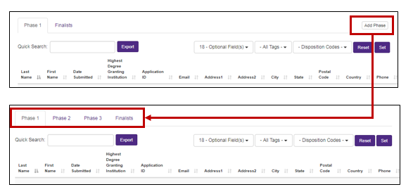

- The use of additional phases is optional, but can help you manage the search process.
  - Phase 1: Lists everyone who submitted an application.
  - Phase 2: Lists everyone you advanced to phase 2.
  - Phase 3: Lists everyone you advanced to phase 3.
  - Finalists: Lists everyone you designated as a finalist.
Phase 1 always contains all applicants to a search, but the other phases can be defined in whatever way is meaningful for your search. For example, the phases could mean:
Phase 1: All applicants
Phase 2: All applicants screened by phone
Phase 3: All applicants invited for a first round interview
Finalists: All applicants invited for a second round interview
A search with few applicants might not need so many phases, so another search process might be:
Phase 1: All applicants
Finalists: All applicants invited for an interview
Note: When applicants are advanced to the next phase, they are not deleted from the prior phase. An applicant advanced to the finalist phase will continue to be listed in all prior phases they had advanced to.

Move Applicant to a Different Search Phase

Note: To use this feature, you must first create search phases (see SECTION 8).
- Open an application (see SECTION 3).
- Make sure you are in the Applicant Information tab and locate the Applicant Phase field:
  - Number: The number tells you which search phase the applicant is in.
  - Minus sign: Press the minus button to move a candidate back to the prior phase (this button only appears if there is a lower phase).
  - Plus sign: Press the plus button to advance a candidate to the next phase (this button only appears if there is a higher phase).
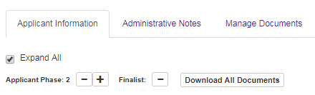
- Navigate back to the Applications tab in the top navigation bar. The phase tabs produce a list of the applicants in each phase. If you advanced an applicant to Phase 2, you should now see the applicant in the Phase 2 tab. When applicants are advanced to the next phase, they are not deleted from the prior phase.
- Alternatively, you may move applicants between phases by going to the Applications tab in the top navigation bar. Click on a phase tab. For the applicants currently in that phase, you may advance them to the next phase or move them back to the prior phase by clicking the plus or minus buttons in the phase column.
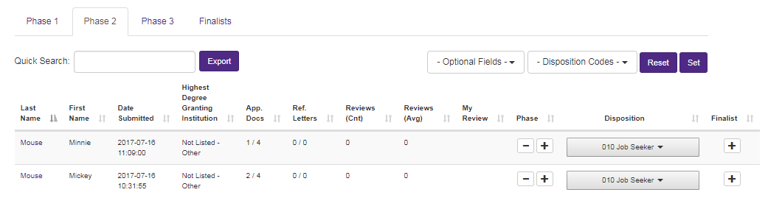

Designate an Applicant as a Finalist

Note: The finalists you designate in FRS will automatically populate into the Search Summary Form produced at the end of the search.
- Open an application (see SECTION 3).
- Make sure you are in the Applicant Information tab. Find the Finalist field and click the plus sign. It will turn into a minus sign, which means the candidate is a finalist. To remove the finalist designation from the candidate, press the minus sign to turn it back into a plus sign.
Note: Yes, this is counterintuitive! A minus sign means the candidate is a finalist.
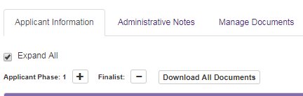
Before (not a finalist)
After (is a finalist)
- Navigate back to the Applications tab in the top navigation bar. Candidates designated as finalists will now appear in the Finalists tab. Finalists will also continue to be listed in the phase tabs (reflecting all phases of the search they went through).
- Alternatively, you may designate applicants as finalists by going to the Applications tab in the top navigation bar. Click on any phase tab that contains the individual(s) who should become finalists. In the Finalist column, press the plus sign to designate an individual as a finalist. Then go to the Finalist tab to see that they appear in the list of finalists. An individual who is a finalist will (counterintuitively) have a minus sign in the finalist column, which can be pressed to remove the finalist designation.

Enter Disposition Codes

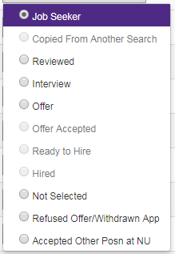
Access: To perform the actions described in this section, you must have access to edit disposition codes. All system users with the role Search Administrator have this access. Search Administrators can also give this access to other staff members by adding them to the search committee and setting their permissions accordingly.
About Disposition Codes: Disposition codes can be used in two ways. First (and optionally), they provide a means by which to track applicant status and review phases of a search. You can assign applicants to disposition codes (e.g., reviewed or interview) and then filter your applicant list by disposition code. The additional and required use of disposition codes is to communicate decisions about applicants to the University. Final disposition codes must be assigned to all applicants by the time you submit a draft offer to FSM for review via the business plan database.
- When an individual applies for a faculty position, a disposition code of “Job Seeker” is automatically assigned. As you conduct the search, you may wish to assign disposition codes of “Reviewed” or “Interview” to track steps of the review process. By the end of the search (when you are proposing a finalist for offer through the FSM business plan database), you must assign one of the following disposition codes to each applicant:
  - Offer – use for the preferred finalist. This individual must be proposed for an offer through FSM’s online business plan database. Occasionally, FSM extends multiple offers from the same HR Job ID; in such cases, the multiple finalists receiving offers should have the disposition code of “Offer.”
  - Not Selected – use this code when the search committee does not choose the applicant as the finalist; you will be asked to supply a disposition code reason from the list below.
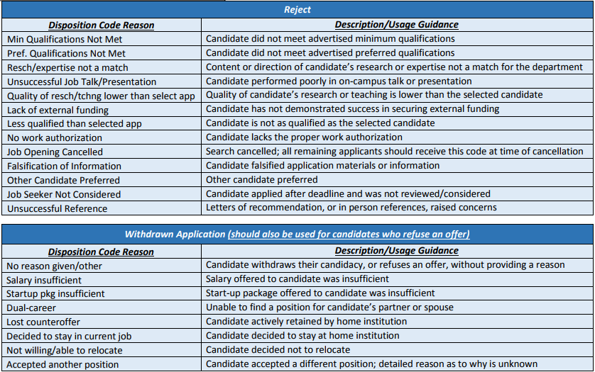
  - Refused Offer / Withdrawn App – use for candidates who withdraw from the application process or refuse an offer; you will also be asked to supply a disposition code reason from the list below.
  - Accepted Other Posn at NU – use this for candidates who:
    - have accepted another position at Northwestern University OR
    - have been offered another position at Northwestern University that they are considering OR
    - are being considered for another position at Northwestern University
Note: If the individual accepted a position at another institution, use the code “Refused Offer / Withdrawn Application” instead.

- Go to the Applications tab in the top navigation menu.
- Within any phase tab, you can assign disposition codes using the dropdown list in the Disposition column.
- To easily search for applicants who do not have one of the final disposition codes applied, you may use the Disposition Codes filter field. Make sure you are in the Phase 1 tab (all applicants appear in this list). Use the filter field to select codes that are not final dispositions (there are three: “Job Seeker,” “Reviewed,” and “Interview”) and then press the Set button. The applicants that appear in the list need final disposition codes entered.
- Alternatively, you may enter disposition codes within an application.
  - Open an application (see SECTION 3).
  - Make sure you are in the Applicant Information tab.
  - Scroll down to find the Applicant Disposition Information panel where you can enter disposition codes.
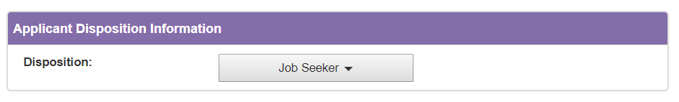

Check How Many Applicants Need Final Disposition Codes Assigned Across Your Searches
In order to extend an offer to your chosen finalist, you must apply final disposition codes to all applicants. FRS offers a means to quickly look across all of your active searches to see how many applicants are missing final disposition codes for each search.
- Log in to FRS (https://facultyrecruiting.northwestern.edu) with your netID and password. If you experience login problems, consult SECTION 1 of this guide.
- You will land on the Dashboard screen. Locate the search you want to review. If you can’t find it, configure your dashboard to display all search statuses to be sure it isn’t hidden from view (SECTION 21).
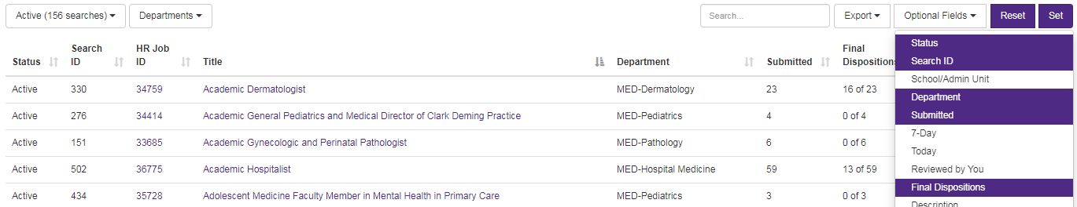
- Look for the Final Dispositions column on the dashboard. This column is not included in your dashboard by default, so you will need to add it if you have not done so previously. To add it, go to the Optional Fields dropdown list. After you have selected Final Dispositions, press the Set button to have the column added to your dashboard.
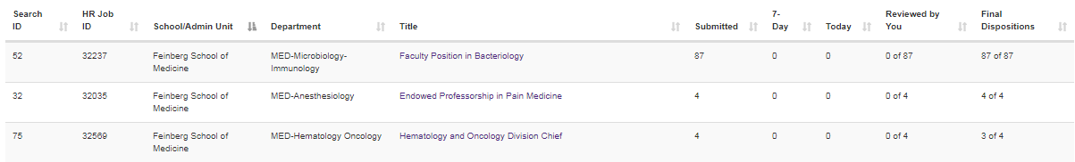
- The Final Dispositions column reports the number of applicants who have been assigned a final disposition code compared to the total number of applicants. If the first and second number are equal (e.g., 87 of 87), then all applicants are dispositioned. If the first number is less than the second number, then there are applicants missing final disposition codes and you need to assign final dispositions before submitting a draft offer for review through the business plan database. See SECTION 11 above for guidance on entering disposition codes.

Download the Search Summary Report

- From the Dashboard tab in FRS, navigate as follows:
  - Click on the Title of the search you want to view. If you can’t find it, configure your dashboard to display all search statuses to be sure it isn’t hidden from view (SECTION 21).
  - Click on the Applications tab in the top navigation bar.
  - Click on the Finalists tab.

- Make sure the list of finalists is complete and correct. If it is not, refer to SECTION 10 of this guide to designate applicants as finalists.

- Make sure that each finalist has a final disposition code assigned (see SECTION 11).

- Press the Search Summary Preview button to generate and download a copy of the Search Summary Report that the Office of the Provost will obtain from the system.

- Provide the Search Summary Report to whomever writes the narrative description of the search process following the search (the narrative search summary appears in the Chair’s Recommendation for Faculty Appointment when the department proposes a candidate for an offer). Make sure the narrative description of the search process and the pre-populated Search Summary Report do not contradict one another.

- The pre-populated Search Summary Report from FRS will be uploaded to the FSM business plan database as part of the offer letter approval process.

Place a Search on Hold / Prevent the Receipt of New Applications
When you submit an offer for review through the business plan database, FSM will typically put your search on hold in FRS to prevent the receipt of new applications that would continue needing final disposition codes assigned. You may desire to put a search on hold sooner.
What Happens When a Search is Placed on Hold?
- In the FRS dashboard, the search status will appear as Hold. You can still execute the search management tasks described in this guide while the search is in hold status.
- The ad stops displaying on the NU Careers site.
- The FRS job application link becomes inactive. Applicants who click on the link will receive a message alerting them that applications are no longer being accepted:
- You won’t receive new applications that continue to need final disposition codes assigned.
Why Place a Search on Hold?
A hold should be placed when you want to prevent new applicants from applying. These are example use cases:
- The search was moved to Active status before the search committee was ready to receive applications. Placing a hold is the mechanism to remove the Active status.
- The search was run for a while but did not yield a finalist; the search committee would like to pause the search and post the ad again later.
- The search is in its final stages and you don’t want to receive additional applications while interviewing finalists.
- You are drafting the offer for the preferred finalist and don’t want to continue applying final disposition codes to new applicants.
- As noted above, FSM will generally place a search on hold in FRS when an offer is received through the business plan database. This locks the applicant list at a point in time. Otherwise, departments need to continue monitoring the search and applying disposition codes until the Provost receives the appointment paperwork (which is typically well after an offer is submitted for review through the business plan database).
How to Place a Search on Hold
- Only the Office of the Provost can change the search status to “hold.” Please contact the FSM Faculty Affairs Office at fao@northwestern.edu and provide the HR Job ID of the search that should be placed on hold. Since there are so many numbers associated with searches (e.g., FRS Search ID, HR Job ID, FAO#) that could be mixed up, it is recommended that your email request includes a screen shot of the search from FRS (the Search Details panel is ideal) to ensure that the right position is placed on hold.
- Once complete, the search will have the status of Hold on your FRS Dashboard.
- Remember to remove any job postings you have placed online since the FRS link contained in it will be inactive. Applicants will see this if they try to apply:

Return a Search to “Active” Status from “Hold” Status

When you are ready to return a search to Active status after placing it on hold, use the process below.
Important: Be mindful of declined offers. If your preferred finalist declines your offer and you need to solicit more applications to identify another finalist, confirm that the search status is “Active” in FRS. The search was probably placed on hold when you extended the offer to your initial finalist, and new applications won’t be received if it remains on hold. However, if the search identified a pool of finalists and you want to extend an offer to another candidate from that pool, you may prefer to leave the search on hold.
How to Return a Search to Active Status
- Only the Office of the Provost can return a search to “active” status after placing it on hold. Please contact the FSM Faculty Affairs Office at fao@northwestern.edu and provide the HR Job ID of the search that should become active. Since there are so many numbers associated with searches (e.g., FRS Search ID, HR Job ID, FAO#) that could be mixed up, it is recommended that your email request includes a screen shot of the search from FRS (the Search Details panel is ideal) to ensure that the right position becomes active.
- Once complete, the search will appear in the Active tab on your FRS Dashboard.

Revise Job Posting or Search Configuration Settings
For each search, a Search Administrator defined the search configuration settings before the search became active in FRS. This section describes how to change the job posting or search configuration settings after a search is active.

Update the Advertisement Posted on the NU Careers Site

Only the Office of the Provost can revise the ads posted on the NU Careers site. To request revisions, please upload a revised ad in tracked changes to the business plan (do not delete the originally approve ad) and alert fao@northwestern.edu. The Faculty Affairs Office will review the revised ad and forward to the Provost’s office to request the changes.

Update the MyHR Search Committee

Only the Office of the Provost can update the MyHR Search Committee. To request changes, please contact fao@northwestern.edu and indicate who should be added to or removed from the MyHR search committee (if removing the person designated as the search chair or equity representative, also indicate who will fill the role instead). If adding search committee members, consider whether the process described below to Add Additional Search Committee Members/Administrators (SECTION 18) could be used instead.
As a reminder, FSM recommends that faculty search chairs and faculty search committee members not be asked to use FRS. If your search committee members are not interacting with FRS, it may not be necessary to update the MyHR search committee, and you could instead describe changes to the search committee in the Chair’s letter at the time of preparing a faculty offer.

Add Additional Search Committee Members/Administrators

- Log in to FRS (https://facultyrecruiting.northwestern.edu) with your netID and password. If you experience login problems, consult SECTION 1 of this guide.
- You will land on the Dashboard screen. Select a search by clicking on its Title, which will open the Overview screen for that search.
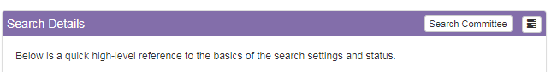
- Click on the Search Committee button at the top of the Search Details panel.
- Locate the Users section: In this panel, you select one or more users from the dropdown list, press the select users button, specify permissions, and press Add User(s) Permissions. The individual(s) selected will then appear under the Additional Search Committee Members/Administrators header (scroll to bottom of page to find), where you can also edit their permissions.
If users are not available for selection in the Users panel, then they need to be added as a system user in FRS. To do that:
- Scroll up to find the System Users tab.
- Click on the plus icon in the upper right corner of the System Users panel
- Enter the netID of the person you want to add
- Then return to the Search Committee tab and execute the steps in the Users panel as describe above

Change the Order of Document Uploads in the FRS Job Application

When the search was configured, a Search Administrator identified what document uploads to collect from applicants as well as the order in which the document fields are displayed to the applicant on the job application. That also controls how documents are ordered in the single PDF generated when you download all documents for an applicant. You may change the order of documents as presented in the application and as downloaded (e.g., move the cover letter to come before the CV):
- From the Dashboard tab in FRS, navigate as follows:
  - Select the tab (typically the Active tab, but possibly the Hold tab) that contains the relevant search.
  - Click on the Title of the search you want to view.
  - Click on the Settings tab in the top navigation bar.
  - Click on the Search Options tab.
- Locate the Document Type panel. Hover your cursor over the Display Order column for the document you wish to move; then drag and drop it higher or lower in the list of documents.

Edit Search Details, Search Administrators, Search Contacts, or Search Options

The Search Details, Search Administrators, Search Contacts, and Search Options (i.e., the degree types dropdown list, the document types collected from applicants, and email templates) can only be edited when a search is in “Pre-Active” status. If any of those items need editing, contact fao@northwestern.edu to revert an active search back to “Pre-active” status. Include a description of the change(s) needed, for FAO will make the change directly if it is more expedient to do.

Other Useful Features
FRS offers more features and functionality than are described in this guide. This section highlights a few additional features that may be useful to you in coordinating a search.

Configure Dashboard

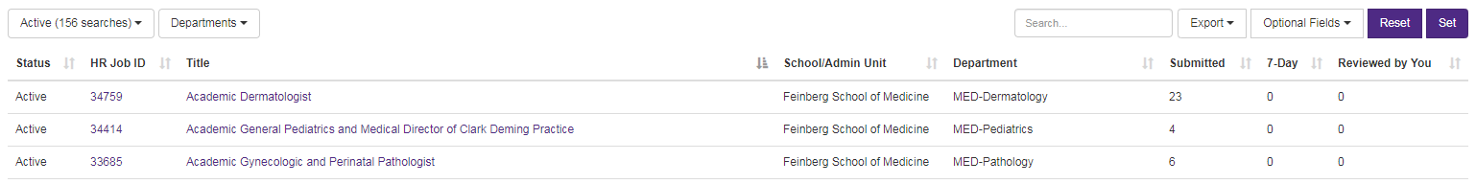
- Default View: By default, the dashboard screen shows only searches that have Active status, and eight columns display in the table. You can change the rows and columns you see using the filters above the table. To change your personal default view, set the filters you desire (see descriptions below) and then press Set to save your preferences. If you later wish to restore the system defaults, press the Reset button.
- Search Status Filter: Use the filter above the Status column to include searches with other statuses on your dashboard. When attempting to configure a search, you will need to see the searches with Pre-Active status. Feinberg recommends selecting all search statuses so that none are hidden from your view when searching.
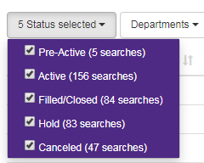
- Department Filter: If you have access to searches in more than one unit, you can use the Departments filter to restrict your view to searches in specific units.
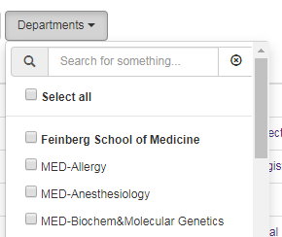
- Optional Fields: Click on the Optional Fields filter to select the columns you wish to view in the table. The selected columns are highlighted in purple; click on an option in the list to select or de-select it. Feinberg recommends including the Final Dispositions column, which will help you track the number of applicants you have assigned final disposition codes to. All applicants must have final disposition codes applied by the time a search concludes.
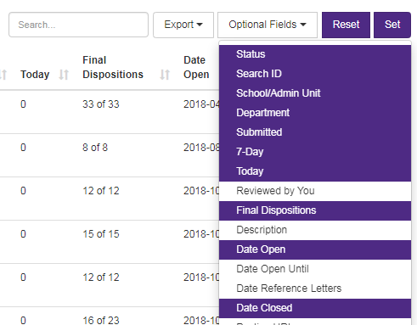
- Save Your Personal Defaults: If you wish to save your selections as your personal defaults, press the Set button. The next time you return to the Dashboard screen, it will be configured according to the preferences you selected.

Create a Custom Tag to Categorize/Track Applicants

FRS offers a means to categorize applicants using a dropdown list that you customize with your own list of options. For example, you might conduct a search for a general position like “cancer specialist” and want to categorize applicants according to the type of cancer they specialize in (e.g., “gynecologic,” “neurologic,” “urologic,” etc.). Or you might have a search that is open to candidates at any academic rank and want to categorize applicants according to the rank they are applying for (e.g., “Assistant Professor,” “Associate Professor,” “Professor”). This feature is available to all FRS users, not just Search Administrators.
Establish the List of Options for Categorizing Applicants
- From the Dashboard tab in FRS, select a search by clicking on its Title, which will open the Overview screen.
- Locate the Custom Tag (e.g., Specialty Area) panel. Click on the plus icon in the upper right corner of the panel and enter the following:
  - Custom Tag: Enter any tag name that would be meaningful to you in categorizing or tracking applicants. The tag that you enter will appear on a dropdown list.
  - Order: Enter a number to indicate where on the dropdown list you want this option to appear.
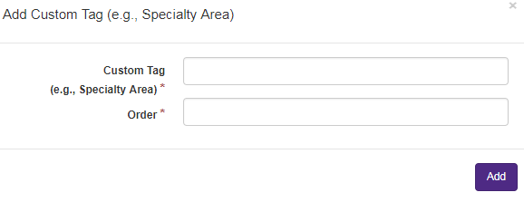
- Repeat step number 2 for each custom tag you want to add to the list. To change any of the options you have entered:
  - Click on the tag name to select it (the row will be highlighted in blue).
  - Then click on the pencil icon (to edit) or the trash can icon (to delete) in the upper right corner of the panel.
Apply a Custom Tag to an Applicant
- From the Dashboard tab in FRS, navigate as follows:
  - Click on the Title of the search to open the Overview screen. Confirm that the Custom Tag (e.g., Specialty Area) panel has custom tags defined.
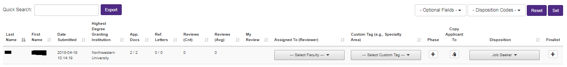
  - Click on Applications in the top navigation bar to open the Applications Summary screen. The table of applicants includes a Custom Tag (e.g., Specialty Area) column (the column only appears if you have defined custom tags on the Overview screen). Use the dropdown list in this column to apply your custom tags to individual applicants. Please note that you can only apply one custom tag to each applicant.

Enter, Edit, or Delete Administrative Notes on Applicant Records

You may find it helpful to record administrative notes on applicant records. This feature is available to Search Administrators and any Search Committee Members or Additional Administrators whose permissions are configured appropriately.
- From the Dashboard tab in FRS, navigate as follows:
  - Click on the Title of the search to open the Overview screen.
  - Click on the Applications tab in the top navigation bar to open the Applications Summary screen.
  - Click on the last name of the desired applicant to open the Application Detail screen.
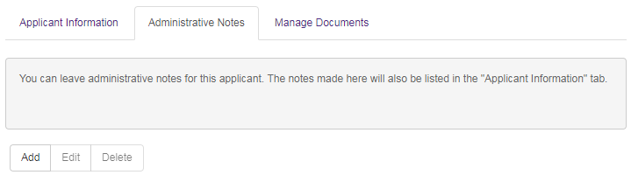
- Click on the Administrative Notes tab and then press Add to enter a note. Type your note and press Add; the note will be displayed on this page. You may also edit or delete notes from this screen using the appropriate buttons.
- The note is also visible or accessible from other locations:
  - Click on the Applicant Information tab and scroll to the bottom of the page. The note you entered is visible in the Administrative Notes panel:
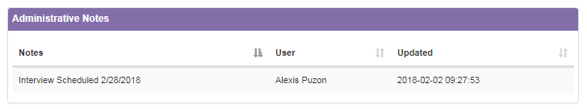
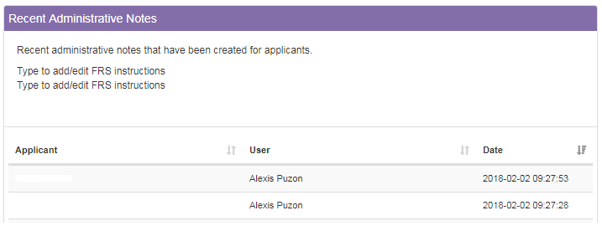
  - Click on the Overview tab in the top navigation bar. Then scroll to the bottom of the screen. The Recent Administrative Notes panel contains a log of the applicants for whom administrative notes were recently entered.

