Using NUcore Data in the Core Utilization Template

I. Exporting Data from NUcore
- In NUcore, go to the Reports tab and choose General from the drop-down menu (green arrow in image).
- Select Fulfilled from the date type drop-down, select a date range of 04/01/2023 to 03/31/24, and include Complete and Reconciled in the Current Order Status box (red box in image).
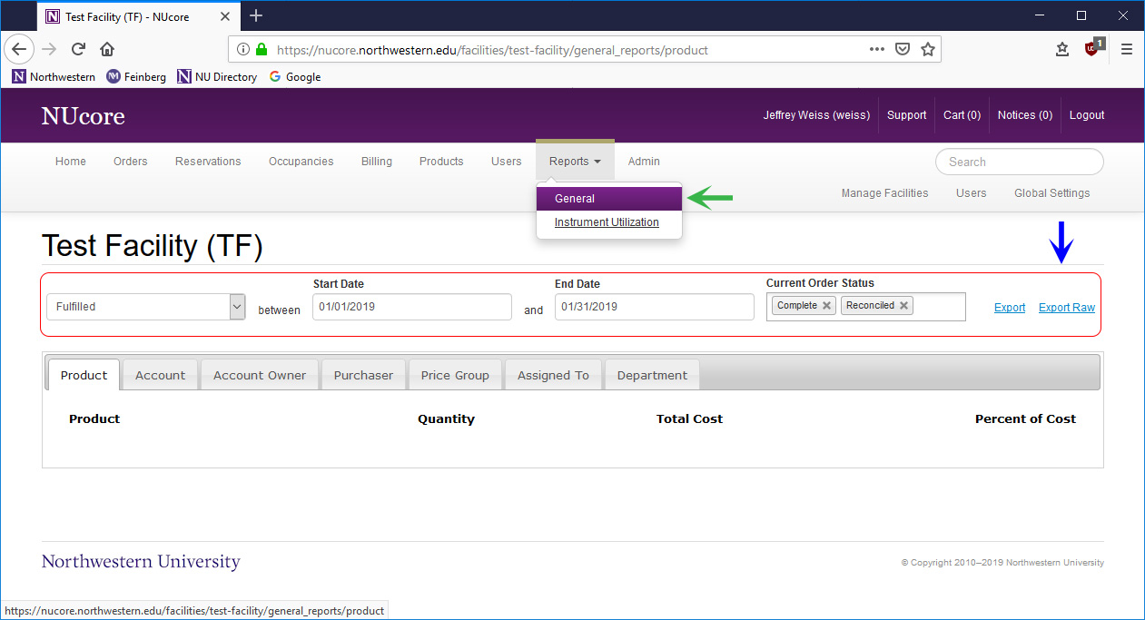
- Wait for the data to update, then click Export Raw (blue arrow in image) to save the data in CSV format. Note that the CSV file will be emailed to you.

II. Using the Activity Template
- Open the CSV file in Excel.
- Copy the data only, excluding the column titles. This will include a range of cells from A2 to the last row in column BU.
- Open the activity template (FY25_core_utilization_template).
- Paste the data beginning in cell A3 on the tab labeled Enter Data on this Tab (image below). This data will automatically populate the other tabs in the spreadsheet.
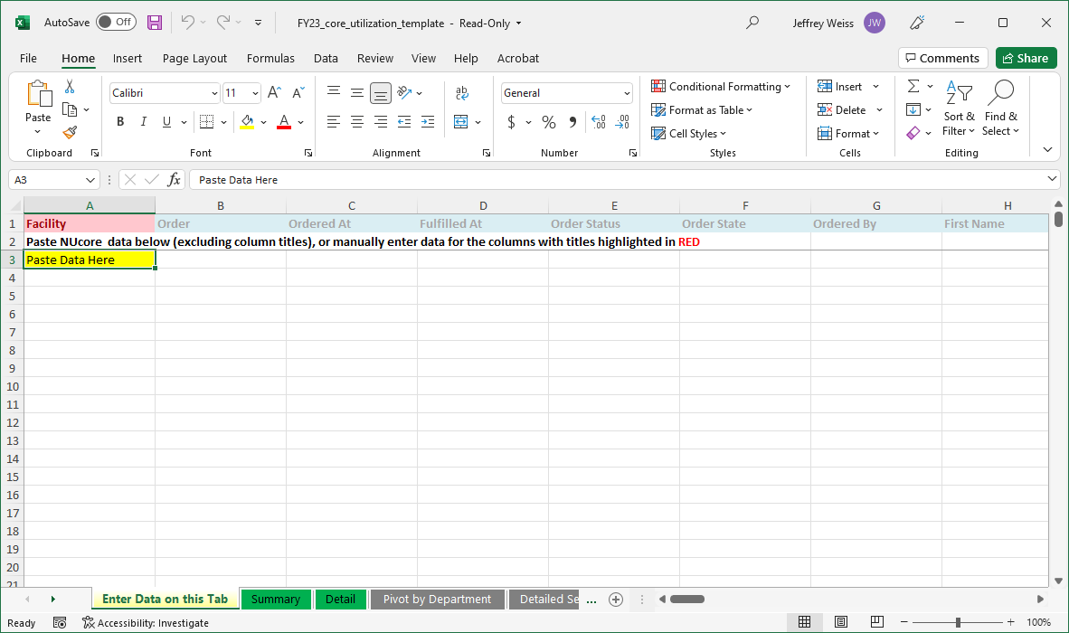
- The tab DO NOT EDIT THIS TAB will now contain those fields that are relevant to the activity report. Note that this tab contains an Excel table with 40,000 lines. If you pasted more than 40,000 lines of data in the first tab (unlikely), you can expand the table & the other tabs will adjust automatically.
Summary data are now available on the Summary and Detail tabs. If you want to see the data pivoted by department/user or by service/user, go to the Pivot by Department or Detailed Services tab of the template and click on Data -> Refresh All.

